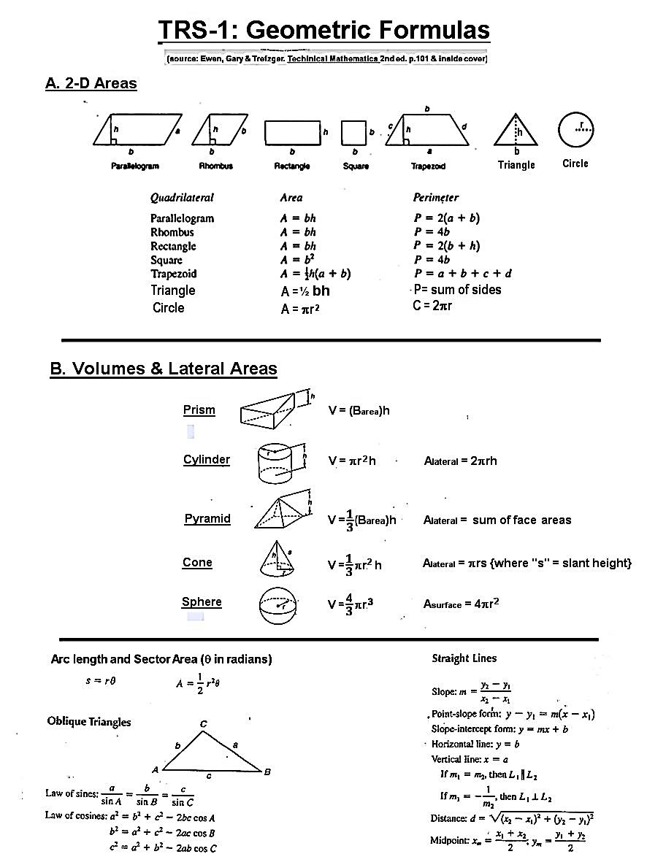

**Alateral** depends on orientation

**1505**

Lateral Area does NOT include top or bottom areas